TITLE OF THE PROJECT

**COMPETITIVE ANALYSIS OF LEADING TRAVEL AGGREGATORS**



**TEAM ID** : LTVIP2023TMID08302

TEAM DEATAILS :

|  |  |  |  |
| --- | --- | --- | --- |
| ROLL NO | NAME | ROLE | EMAIL |
| SBAP0008301 | Rayala Babasai | TEAM  MEMBER | Babasairayala@Gmail.Com |
| SBAP0008302 | Raji S | TEAM LEADER | Rajisunkara1234@Gmail.Com |
| SBAP0008303 | S GNayana | TEAM  MEMBER | Nayana200213@Gmail.Com |
| SBAP0008304 | SATHAMBAKAM KISHORE | TEAM  MEMBER | Kishoresathambakam@Gmail.Com |
| SBAP0008305 | SYED AKRAMHUSSAIN | TEAM  MEMBER | [Akram110202@Gmail.Com](mailto:Akram110202@Gmail.Com) |
| SBAP0008306 | T Saipoojitha | TEAM  MEMBER | Thogantisaipoojitha24@Gmailcom |

**Define problem/problem understanding**

* **Specify the business problem**
* **Business requirements**
* **Literature Survey**
* **Social or Business Impact.**
* **Specify the business problem :-**
* **Competition from other travel aggregators.** The travel aggregator industry is very competitive, with a number of large players vying for market share. This can make it difficult for travel aggregators to differentiate themselves and attract customers.
* **Dependence on third-party suppliers.** Travel aggregators typically do not own any of the travel products that they sell. Instead, they rely on third-party suppliers, such as airlines, hotels, and car rental companies. This can make it difficult for travel aggregators to control their costs and ensure that they are offering the best possible prices to customers.
* **Rising costs of customer acquisition.** Travel aggregators spend a lot of money on marketing and advertising in order to acquire new customers. This can be a major challenge, especially in a competitive market.
* **Difficulty in differentiating their offerings.** With so many travel aggregators competing for customers, it can be difficult for any one aggregator to stand out from the crowd. This is especially true when the products and services that they offer are similar to those of their competitors.
* **Keeping up with changing consumer demands and preferences.** The travel industry is constantly changing, and consumer demands and preferences are constantly evolving. This can make it difficult for travel aggregators to keep up with the latest trends and ensure that they are offering the products and services that customers want.

These are just a few of the business problems that travel aggregators face. By understanding these challenges, travel aggregators can develop strategies to overcome them and succeed in the competitive travel industry.

Here are some additional tips for specifying the business problem for travel aggregators:

* **Focus on the most important problems.** Not all problems are created equal. Focus on the problems that are having the biggest impact on your business.
* **Quantify the problems.** How much money are you losing because of the problem? How many customers are you losing? Quantifying the problem will help you to understand its impact and to prioritize it.
* **Get input from others.** Talk to your customers, employees, and other stakeholders to get their input on the problems. This will help you to get a better understanding of the problems and to identify potential solutions.
* **Business requirements :-**
* **The ability to aggregate travel products from a wide range of suppliers.** This includes airlines, hotels, car rental companies, and tour operators.
* **The ability to compare prices from different suppliers.** This allows customers to find the best possible deals on travel products.
* **The ability to book travel products directly through the travel aggregator's website or app.** This makes it easy for customers to book their travel without having to go through multiple websites or apps.
* **The ability to provide customer support.** This includes answering questions about travel products, resolving problems, and providing refunds.
* **The ability to track customer behavior.** This allows travel aggregators to understand what products and services customers are interested in and to target their marketing accordingly.
* **The ability to personalize the customer experience.** This includes recommending products and services that are likely to be of interest to the customer, based on their past travel behavior.
* **The ability to provide a secure and reliable platform.** This is essential for protecting customer data and ensuring that transactions are secure.

These are just some of the business requirements for travel aggregators. The specific requirements will vary depending on the specific business and the target market.

Here are some additional tips for writing business requirements for travel aggregators:

* **Be specific.** The more specific you can be about the requirements, the easier it will be to develop a system that meets your needs.
* **Use clear and concise language.** Avoid jargon and technical terms that the business users may not understand.
* **Prioritize the requirements.** Not all requirements are created equal. Prioritize the requirements so that you can focus on the ones that are most important to the business.
* **Get input from others.** Talk to the business users, stakeholders, and technical team to get their input on the requirements. This will help you to get a better understanding of the requirements and to identify any potential problems.
* **Literature Survey :-**
* **"The Impact of Online Travel Agencies on the Travel Industry"** by Rui Chen and Wei Wu (2018). This paper examines the impact of online travel agencies (OTAs) on the travel industry. The authors find that OTAs have had a significant impact on the industry, leading to increased competition, lower prices, and more choice for consumers.
* **"Consumers' Purchase Intention of Hotel Aggregators: A Consumption Value Perspective"** by Sachin Luthra and Deepak Sharma (2023). This paper examines the factors that influence consumers' purchase intention of hotel aggregators. The authors find that consumers' perceived value of hotel aggregators is the most important factor influencing their purchase intention.
* **"The Role of Online Reviews in the Travel Industry"** by Xinran Wang, Wei Wu, and Rui Chen (2019). This paper examines the role of online reviews in the travel industry. The authors find that online reviews have a significant impact on consumers' travel decisions, leading to increased sales for hotels and other travel providers.
* **"The Future of Travel Aggregators"** by Simon Breakspear (2022). This article discusses the future of travel aggregators. The author argues that travel aggregators will continue to grow in popularity in the coming years, as they offer consumers a convenient and easy way to book travel products.
* **"How to Build a Successful Travel Aggregator"** by Neil Patel (2021). This article provides tips on how to build a successful travel aggregator. The author discusses the importance of having a strong business model, a great team, and a clear vision for the future.
* **Social or Business Impact**

**Social Impact**

* **Increased access to travel.** Travel aggregators make it easier for people to book travel, regardless of their budget or location. This has led to an increase in travel among people from all walks of life.
* **More informed travel decisions.** Travel aggregators provide consumers with access to a wealth of information about travel products and services. This allows consumers to make more informed travel decisions, which can lead to a better travel experience.
* **Promotes sustainability.** Some travel aggregators offer green travel options, such as carbon offsetting. This helps to promote sustainable travel practices and reduce the environmental impact of travel.

**Business Impact**

* **Increased competition.** The rise of travel aggregators has led to increased competition in the travel industry. This has forced travel providers to lower prices and improve their services in order to compete.
* **More choice for consumers.** Travel aggregators offer consumers a wider choice of travel products and services. This gives consumers more control over their travel plans and allows them to find the best deals.
* **Increased revenue for travel providers.** Travel aggregators can generate revenue for travel providers through commissions and advertising. This helps to increase the revenue of travel providers and can lead to job creation.

Overall, travel aggregators have had a positive social and business impact. They have made travel more accessible, informed, and sustainable. They have also increased competition in the travel industry, which has led to lower prices and more choice for consumers.

Here are some additional thoughts on the social and business impacts of travel aggregators:

* **Travel aggregators have made it easier for people to travel to new places and experience different cultures.** This can lead to increased understanding and tolerance between people from different backgrounds.
* **Travel aggregators have helped to create jobs in the travel industry.** This includes jobs in customer service, marketing, and technology.
* **Travel aggregators have helped to boost the economies of tourist destinations.** This is because tourists spend money on hotels, restaurants, and other goods and services while they are traveling.

Of course, there are also some potential negative impacts of travel aggregators. For example, they could lead to a decrease in the number of independent travel agents, as people increasingly book their travel online. Additionally, some people argue that travel aggregators can make it too easy to book travel, which can lead to people making impulsive decisions that they later regret.

Overall, the social and business impacts of travel aggregators are complex and multifaceted. However, there is no doubt that they have had a significant impact on the travel industry.

* **Data Collection & Extraction From Database**

**Data collection is the process of gathering and measuring information on variables of interest, in an established systematic fashion that enables one to answer stated research questions, test hypotheses, and evaluate outcomes and generate insights from the data.**

* **Collect The Dataset**

* **Kaggle public websites.** This is a common way to collect data for travel aggregators. You can use a web crawler to scrape data from websites such as Expedia, Booking.com, and TripAdvisor.
* **Use APIs.** Some travel providers offer APIs that allow you to access their data programmatically. This can be a good way to collect data for specific travel products or services.
* **Purchase data sets.** There are a number of companies that sell datasets related to travel. This can be a good option if you need a large dataset or if you need data that is not available through other means.
* **Conduct surveys.** You can also collect data by conducting surveys of travelers. This can give you insights into their travel preferences and behaviors.

Once you have collected your data, you will need to clean it and prepare it for analysis. This includes removing duplicate data, correcting errors, and formatting the data so that it is easy to use.

Once your data is cleaned and prepared, you can start to analyze it. This can help you to understand the travel market, identify trends, and develop new marketing strategies.

Here are some of the factors that you might want to consider when collecting a dataset for travel aggregators:

* **The type of data.** You will need to decide what type of data you need to collect. This could include data on travel products, prices, availability, reviews, and demographics.
* **The scope of the data.** You will need to decide how broad or narrow the scope of your dataset will be. For example, you could collect data on all travel products or you could focus on a specific type of travel product, such as flights or hotels.
* **The quality of the data.** It is important to collect high-quality data. This means that the data should be accurate, complete, and up-to-date.
* **The cost of the data.** Collecting data can be expensive. You will need to factor in the cost of data collection when making your decision.
* **Connect IBM DB2 With IBM Cognos**



To connect IBM DB2 with IBM Cognos, you will need to create a data source connection in Cognos. The steps on how to do this are as follows:

1. In Cognos, go to **Administration** > **Data Source Connections**.
2. Click the **New Connections** icon (+).
3. In the **Data Source Type** drop-down list, select **IBM DB2**.
4. In the **Name** field, enter a name for the data source connection.
5. In the **Server Name** field, enter the hostname or IP address of the DB2 server.
6. In the **Port** field, enter the port number for the DB2 server.
7. In the **Database Name** field, enter the name of the DB2 database.
8. In the **User ID** field, enter the user ID for the DB2 database.
9. In the **Password** field, enter the password for the DB2 database.
10. Click **Save**.

Once you have created the data source connection, you can use it to create reports and analyses in Cognos.

Here are some additional tips for connecting IBM DB2 with IBM Cognos:

* **Make sure that the DB2 driver is installed on the Cognos server.** The DB2 driver is a software component that allows Cognos to connect to DB2 databases.
* **Use the correct security mechanism.** The security mechanism determines how Cognos authenticates users when they connect to the DB2 database. The default security mechanism is **Integrated Security**.
* **Configure the data source connection for optimal performance.** You can configure the data source connection to optimize performance for your specific needs. For example, you can specify the maximum number of connections that Cognos can make to the DB2 database.
* **Data Visualization**

Data visualization is the process of creating graphical representations of data in order to help people understand and explore the information. The goal of data visualization is to make complex data sets more accessible, intuitive, and easier to interpret. By using visual elements such as charts, graphs, and maps, data visualizations can help people quickly identify patterns, trends, and outliers in the data.

* **The No Of Unique Visualizations**

The number of unique visualizations that can be created with a given dataset. Some common types of visualizations that can be used to analyse the travel aggregators data include bar charts, line charts, heat maps, scatter plots, pie charts, Maps etc. These visualizations can be used to compare performance, track changes over time, show distribution, and relationships between variables

* **Dashboard**

A dashboard is a graphical user interface (GUI) that displays information and data in an organized, easy-to-read format. Dashboards are often used to provide real-time monitoring and analysis of data, and are typically designed for a specific purpose or use case. Dashboards can be used in a variety of settings, such as business, finance, manufacturing, healthcare, and many other industries. They can be used to track key performance indicators (KPIs), monitor performance metrics, and display data in the form of charts, graphs, and tables.

* Responsiveness And Design Of A Dashboard

The responsiveness and design of a dashboard for analysing the factors important for analysis of travel aggregators is crucial to ensure that the information is easily understandable and actionable. Key considerations for designing a responsive and effective dashboard include user-centred design, clear and concise information, interactivity, data-driven approach, accessibility, customization, and security. The goal is to create a dashboard that is user-friendly, interactive, and data-driven, providing actionable insights

Once you have created views on different sheets in IBM Cognos, you can pin them and pull them into a dashboard.

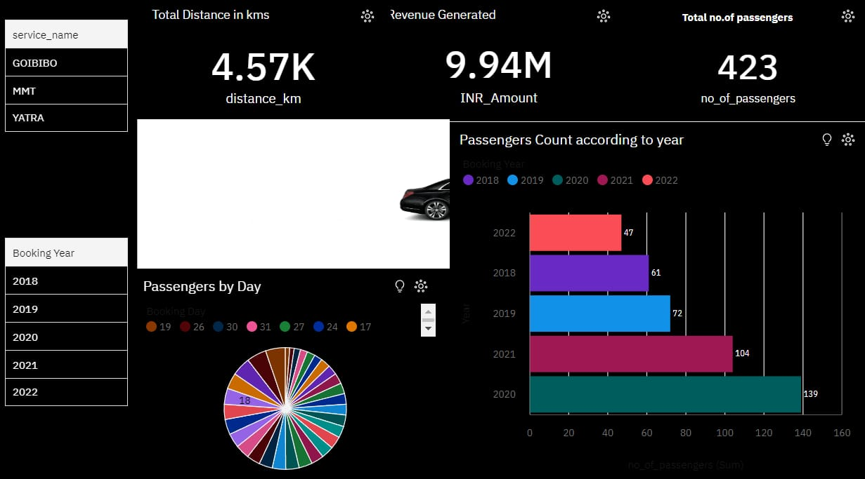

* **Story**

A data story is a way of presenting data and analysis in a narrative format, with the goal of making the information more engaging and easier to understand. A data story typically includes a clear introduction that sets the stage and explains the context for the data, a body that presents the data and analysis in a logical and systematic way, and a conclusion that summarizes the key findings and highlights their implications. Data stories can be told using a variety of mediums, such as reports, presentations, interactive visualizations, and videos.

* **The Number Of Scenes In A Storyboard**

The number of scenes in a storyboard for a data visualization analysis of the factors affecting the selection of travel aggregators, will depend on the complexity of the analysis and the specific insights that are trying to be conveyed. A storyboard is a visual representation of the data analysis process and it breaks down the analysis into a series of steps or scenes.

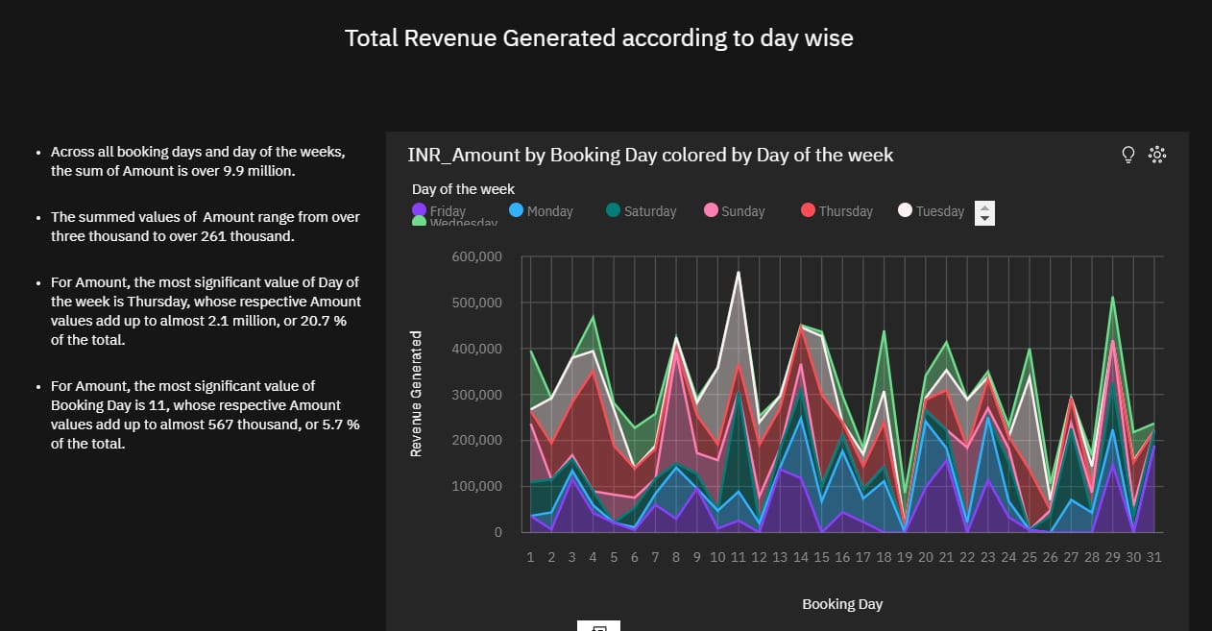

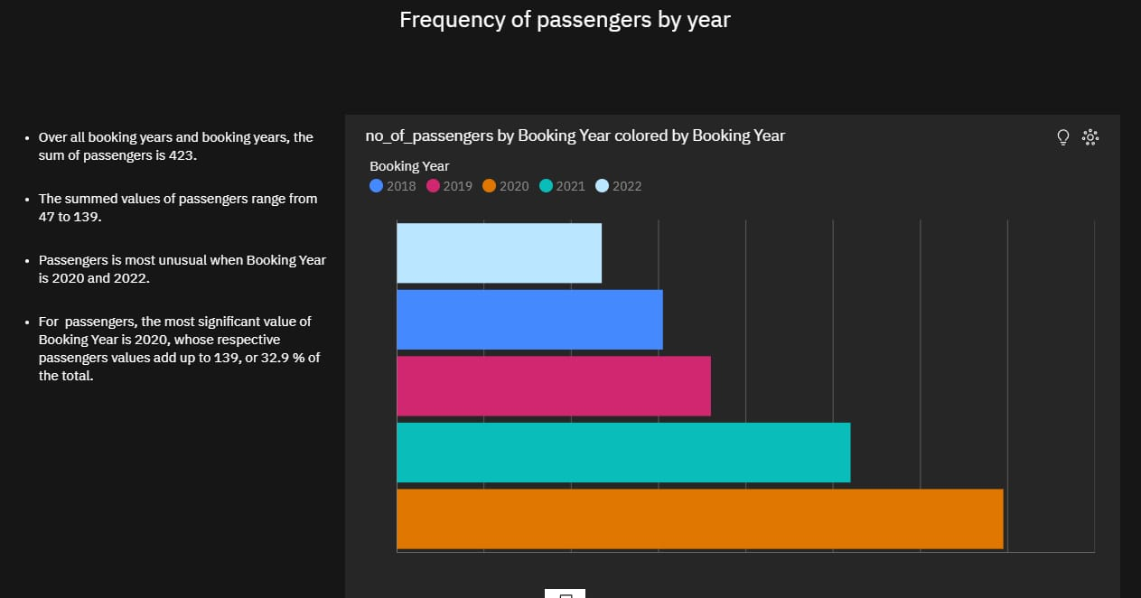

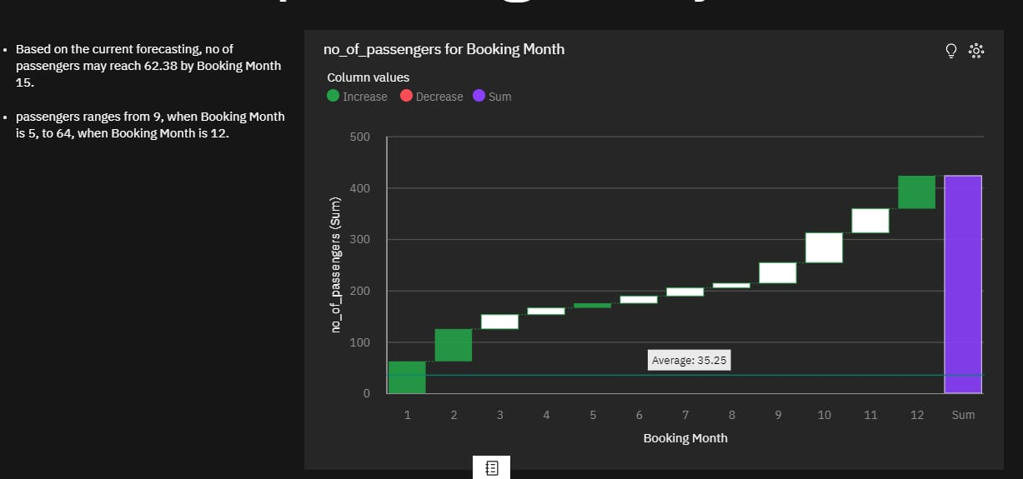

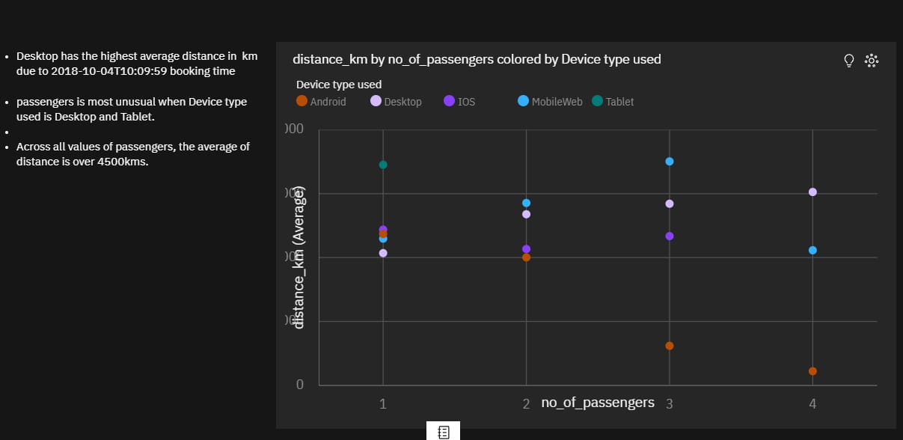

* **Report**

A report is a document that presents information in a specific format and layout, usually based on data from a database or other data source. A report in IBM Cognos can contain various elements, such as tables, charts, graphs, and images, as well as text and data elements, and it is designed to be used by business users to help them better understand their data and make informed decisions. There are several different types of reports available in IBM Cognos, including list reports, crosstab reports, chart reports, and report studio reports, among others. The type of report that you choose will depend on the specific needs and requirements of your organization, as well as the data that you need to present.

* **Performance Testing**
* **Amount Of Data Rendered To DB2**

The amount of data that is rendered to a database depends on the size of the dataset and the capacity of the database to store and retrieve data.

* **Utilization Of Data Filters**

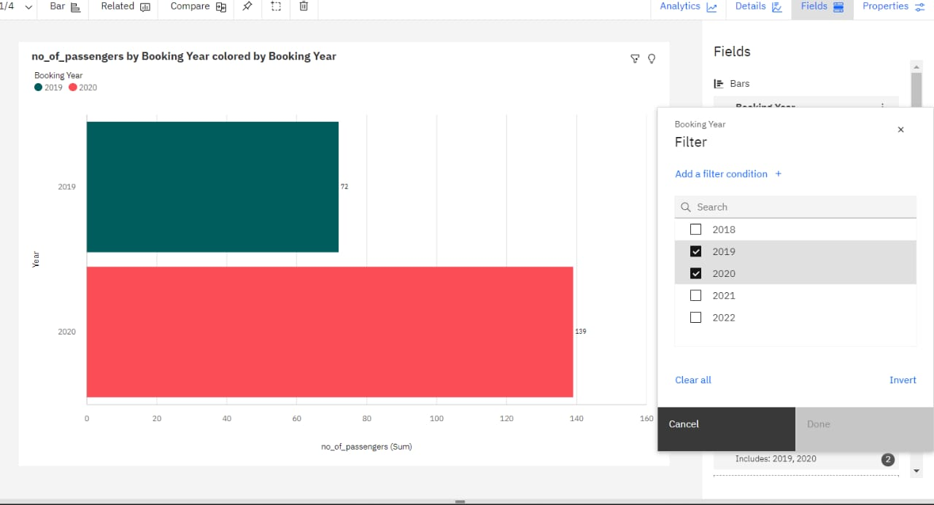

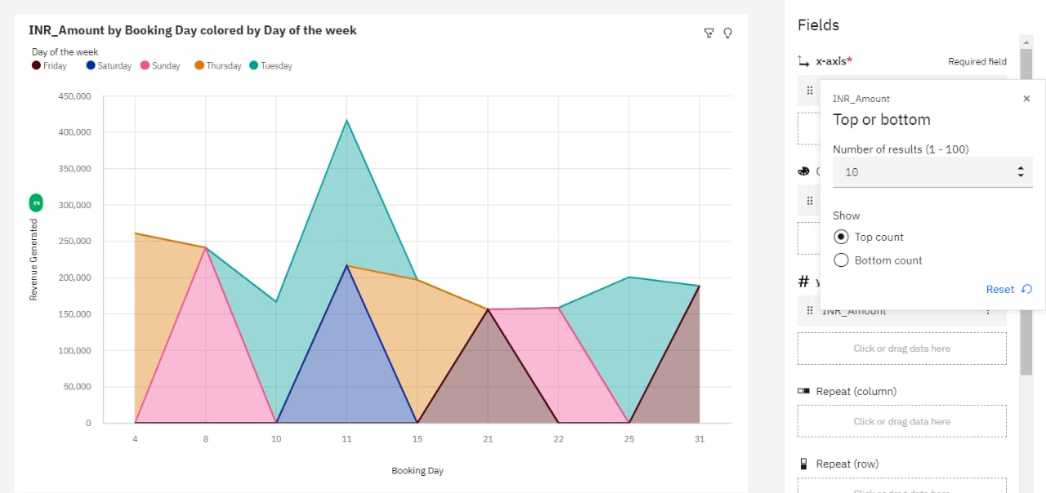

* **No Of Calculation Fields**

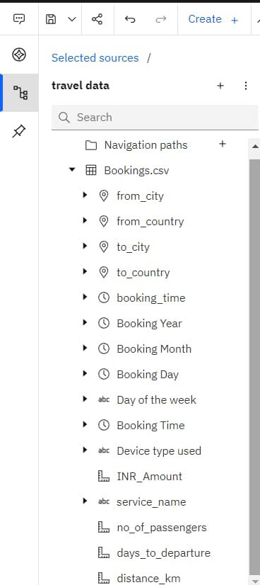

* **No Of Visualizations/ Graphs**

1. Total Distance covered by the Agencies
2. Total Revenue Generated and Total No of Passengers
3. Passenger Analysis according to the day of the month
4. Passenger Analysis according to the year
5. Passenger Analysis as per Destination Country and City
6. Passenger Analysis as per Source Country and City
7. Total Revenue Generated According to day wise
8. Passenger bookings platform analysis

* **Web Integration**

Publishing helps us to track and monitor key performance metrics, to communicate results and progress. help a publisher stay informed, make better decisions, and communicate their performance to others.

Integrating dashboard/reports/stories to web

Step 1: Go to Dashboard/story/report, click on share button on the top ribbon

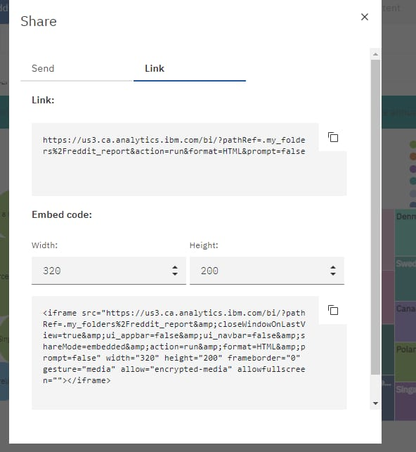

* **Dashboard, Report And Story Embed With UI With Flask**

**1.Create a Flask app.** You can use the flask package to create a Flask app.

**2.Import the dash package.** The dash package provides the tools you need to embed dashboards, reports, and stories in Flask

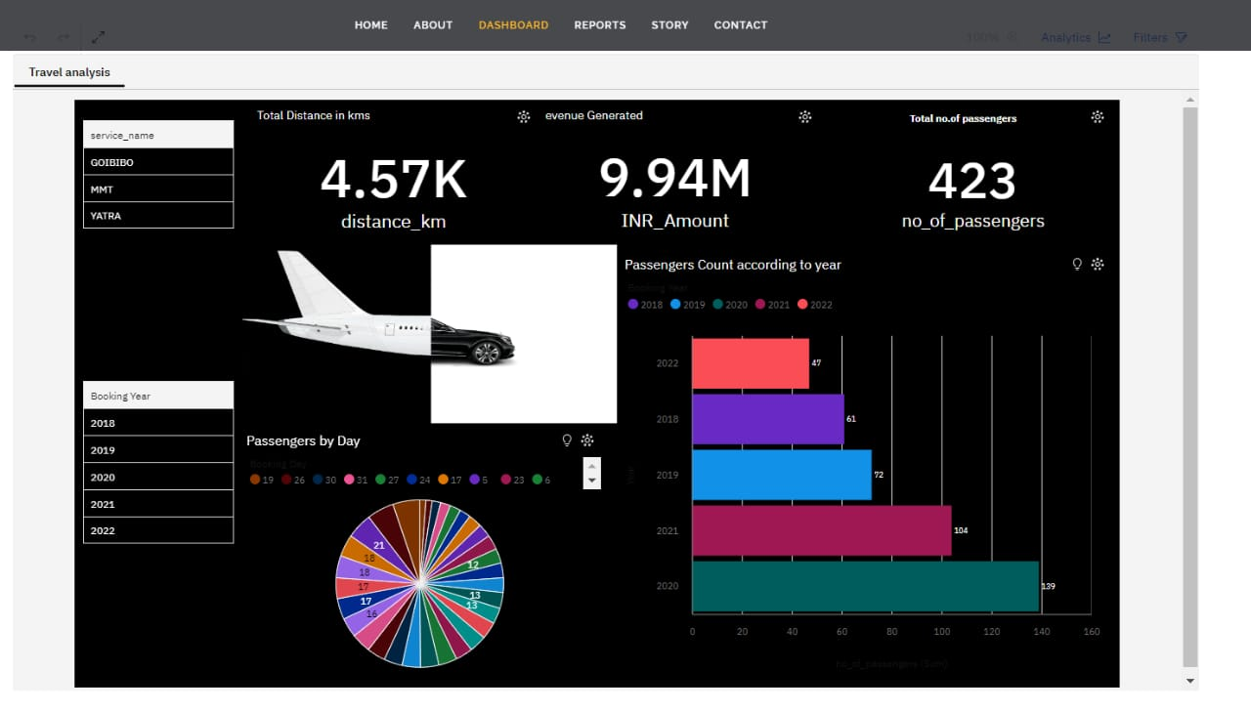

3. **Create a dashboard, report, or story.** You can use the dash package to create a dashboard, report, or story.

4..**Embed the dashboard, report, or story in Flask.** You can use the dash.embed() function to embed a dashboard, report, or story in Flask.

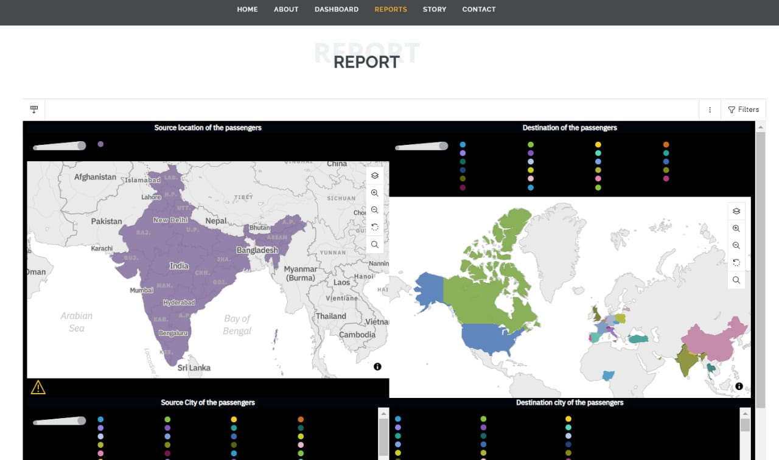

* id: The ID of the dashboard, report, or story to be embedded.
* url: The URL of the dashboard, report, or story to be embedded.
* title: The title of the dashboard, report, or story to be embedded.

